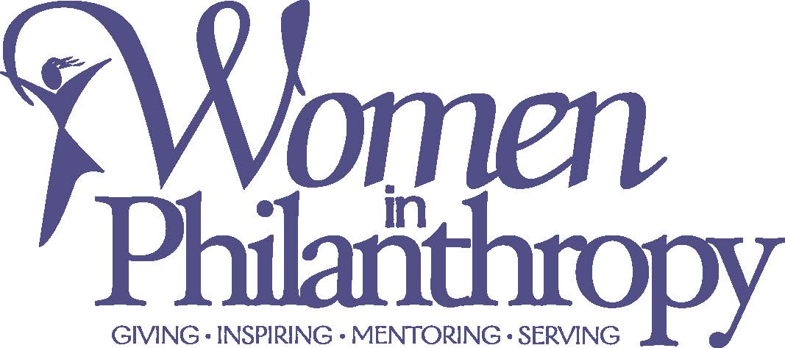

2021 Letter of Intent

Once completed, please email directly to Kari Sisk, MCCF Program Director: ksisk@madisonccf.org

Name of organization:
Contact Person, phone, email:
Location of organization:
Briefly explain your organization:
Title of Program/Project:
Briefly explain the program/project; be sure to answer the “Who, What, Why, How:”
Requested Grant Amount:
Total Project Amount:

You will be contacted should the WIP committee invite you to complete a full application.

