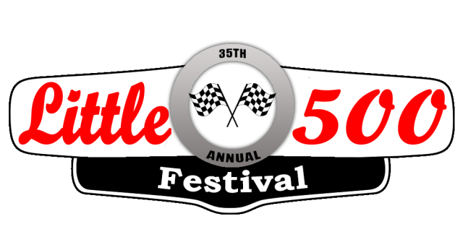

Little 500 Festival Queen Contest Guidelines

BACKGROUND: The Little 500 Festival generates community awareness and excitement preceding the Lucas Oil Little 500 Sprint Car Race. The nationally sanctioned race draws thousands of spectators and sprint car drivers annually from as far away as California, Florida, Europe, and Australia.

The role of the Little 500 Festival Queen is to appear at events during the month of May around the community to help promote the festival as well as attend the Little 500 race at Anderson Speedway on Saturday, May 28, 2022. The Queen will receive a $2500 scholarship and the first runner-up will receive a $1000 scholarship.
RULES:
- Judging and interviews will take place on April 7. Interviews will be conducted via Zoom.
- Entrants must agree to abide by the rules of the queen scholarship committee and must make appearances at certain events during the month of May to promote the Little 500 Festival.
- Entrants must be females between the ages of 17 and 21 and be a resident of Madison County, and/or a college student living in Madison County during the 2021-2022 school year.
- Entrants must be of good moral character and shall not have been convicted of any crimes.
- Applicants must complete the attached application, a 250 word essay on attached prompt, and a copy of driver’s license by Friday, March 25.
  - 250 word essay: What is the most rewarding community volunteer experience you have ever had and why?
- Entrants must not have been awarded Queen in the past, runner ups may re-apply.
- The scholarship awarded to the Queen and First Runner Up will be sent to the appropriate post-secondary educational institution upon proof of enrollment for the 2021-2022 school year. If the queen or runner up is a junior or senior in high school, the check will be held until proof of enrollment in a post-secondary educational institution is provided.

An independent panel of judges will interview the contestants. Interview judging is based on poise, ability to carry a conversation, application answers, and personality.

Please email your completed application, essay, copy of driver’s license, and a JPEG photo to: AndersonLittle500Festival@gmail.com by March 25, 2022.
Please contact the Festival Queen Committee at 317-498-3292 or AndersonLittle500Festival@gmail.com with any questions.

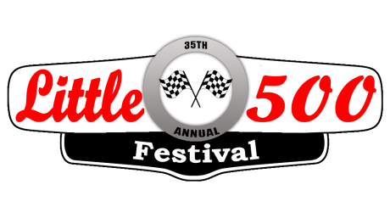

2022 Little 500 Festival Queen Application
Name_____________________________________________________________________________________
Address______________________________________________________ City ____________ Zip _________
Phone _____________________________ Date of Birth____________________
Parent Name(s): ____________________________________________________________________________
High school or college currently attending ____________________________________G.P.A. _____________
Future Plans or Ambitions: ___________________________________________________________________
__________________________________________________________________________________________
Awards, Honors, Scholarships, or Professional Achievements: _______________________________________
__________________________________________________________________________________________
Clubs / Organization Memberships: ____________________________________________________________
__________________________________________________________________________________________
Athletics or Intramural Sports: _________________________________________________________________
__________________________________________________________________________________________
Community Service and Community Involvement: ________________________________________________
__________________________________________________________________________________________
Hobbies and Interests: ______________________________________________________________________
__________________________________________________________________________________________
What do you consider your greatest personal accomplishment? ______________________________________
__________________________________________________________________________________________
If selected as Little 500 Festival Queen, are you available to make appearances at various events during the month of May? ___________
If you have prior commitments on certain dates, please list ___________________________________

In no more than 250 words please share “What is the most rewarding community volunteer experience you have ever had and why?”

I hereby agree to abide by the Little 500 Festival scholarship rules and agree that the decision of the judges is final. I have read a copy of the attached guidelines and understand any information provided on application may be verified. If selected, I agree to be available on April 7 (after school) for an interview. If selected as the Queen or Runner-Up I agree to attend the Little 500 on Saturday, May 28, 2022.

Applicant Initials ________________ Date _____________Parent/Guardian’s signature (if under 18)_______________Date __________
Please email the following to AndersonLittle500Festival@gmail.com by Friday, March 25, 2022:

- Completed application
- Essay Response

- Copy of driver’s license
- JPEG photo

